Sunday Worship

Scots Church Adelaide

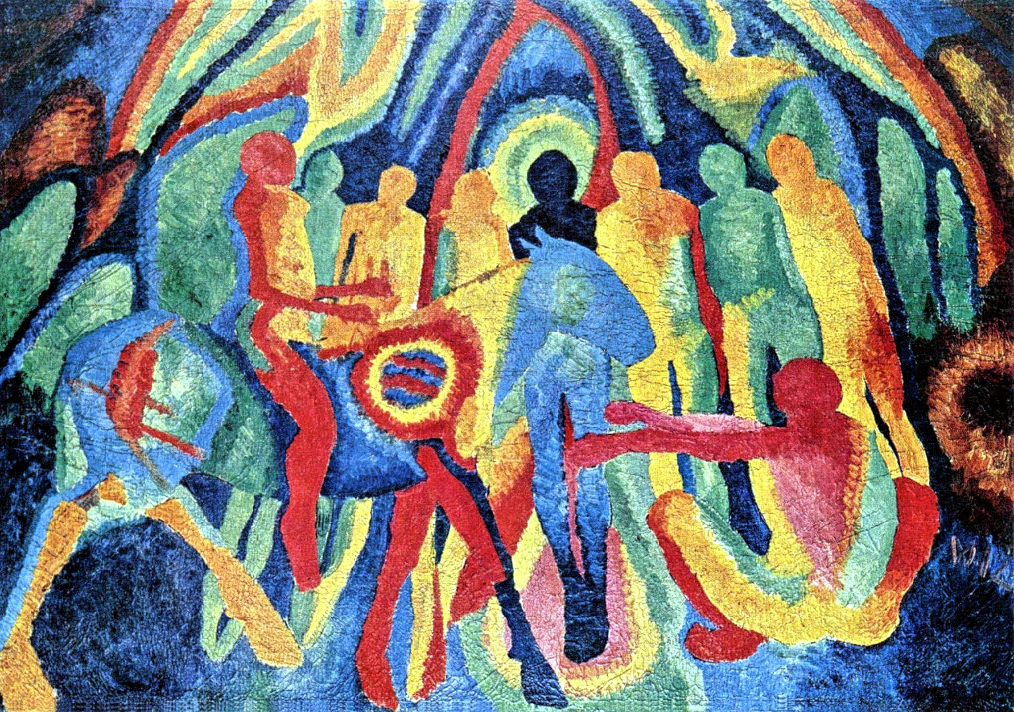

Palm Sunday 29th March 2026

Scots Church Adelaide is a welcoming,
inclusive, and worshipping community of God,
committed to justice, learning and care,
anticipating a world transformed by the love of God.

Scots Church Adelaide acknowledges that we gather on Kaurna Country, and we pay respect to Elders past, present and emerging. We recognise and respect their culture, beliefs and relationship with the land.

Welcome

An asterisk * indicates that we stand as we are able.
We are invited to speak the words in bold italics.
Helpful instructions and explanations are in italics.
If you require the hearing loop, please sit in the middle of the centre pews.

Meditation
In 1912, a year before the first shots were fired in the First World War, the German artist Wilhelm Morgner painted Entry of Christ into Jerusalem. Morgner was drafted in 1913 and, in 1917, at the age of 26, was killed in Flanders.

The painting, just like Jerusalem during Passover, is claustrophobic with chaos. The Passover was a celebration of God’s deliverance in the Exodus, and yet Jerusalem was dominated by colonising Roman soldiers. Jesus, riding into the city in the way a conquering commander would, signals a new—but radically different—deliverance.

It is possible to read the circles on the animal’s shoulder as a target. By riding into the maelstrom of the events as he does, Jesus triggers both prophetic hope and the events that lead to his arrest and execution.

Prelude

The music of the prelude invites us to quieten our busy minds and prepare to worship.

*Processing of the Bible

We stand and together bring the Bible to the centre of our worship service,
expecting to learn and be inspired.

Lighting the Candle

The candle’s flame represents the presence of God with us now and always.

Then God said, “Let there be light,” and there was light.
Light shining in the darkness

The light of creation
The light of the world

(from the Book of Genesis: 10th–5th century BCE
and the Gospel of John late 1st century CE)

Call to Worship

We remind ourselves that we are here to worship God together.

Lift up your eyes;
this is the day God has made.
Lift up your hearts;
your life is a gift from the creator.
Lift up your eyes;
see the world, it is full of the life of God.
Lift up your hearts;
And welcome the God who is always present.

(Uniting Church in Australia: 21st century CE)

*A Hymn of Praise 560 All my hope on God is founded

1. All my hope on God is founded;
all my trust he will renew,
through all change and chance he guides me,
only good and only true.
God unknown,
he alone
calls my heart to be his own.

2. Human pride and earthly glory,
sword and crown betray our trust;
all we build with care and labour,
tower and temple, fall to dust.
But God's power,
hour by hour,
is my temple and my tower.
3. God's great goodness lasts for ever,
deep his wisdom, passing thought;
splendour, light and life attend him,
beauty springing out of naught.
Evermore
from his store
new-born worlds rise and adore.
4. Daily the almighty giver
will his bounteous gifts bestow;
in his will our souls find pleasure,
leading us where'er we go.
Love will stand
at his hand,
joy shall wait for his command.
5. Still from earth to God eternal
sacrifice of praise be done,
high above all praises praising
for the gift of Christ his Son.
Hear Christ call
one and all:
those who follow shall not fall.

Psalm 100

The Hebrew Psalms are an ancient collection of poems long used in Christian worship.

Make a joyful noise to the Lord, all the earth.
Worship the Lord with gladness;

come into God’s presence with singing.
Know that the Lord is God.
It is God who made us,
we are God’s people, and the sheep of God’s pasture.

Enter God’s gates with thanksgiving,
and God’s courts with praise.

Give thanks to God, bless God’s name.
For the Lord is good;
God’s steadfast love endures forever,
and God’s faithfulness to all generations.

(Psalm 100: 10th–5th century BCE)

Prayer

This prayer acknowledges that God is with us and helps us experience God’s presence.

God of all goodness,
we know that you open the eyes of the blind.
You lift up those who are bowed down.
You watch over the stranger.
You uphold the orphan and the widow.
You execute justice for the oppressed.
You give food to the hungry.
You set the prisoner free.
You bring the wicked to ruin.
The world belongs to you
and all creation is in your care.
Amen.
(Uniting Church in Australia: 21st century CE)
Prayer of Confession

We are made in the image of God, but so often do not fully live this truth. We do much to damage ourselves and each other. In confession, we acknowledge these hard truths and open ourselves to God’s forgiveness, which comes to us abundantly.

Before God, we confess:

I sometimes forget
that I was created for Joy.
My mind is too busy.
My Heart is too heavy
for me to remember
that I have been
called to dance
the Sacred dance of life.
I was created to smile
To Love
To be lifted up
And to lift others up.
O’ Sacred One
Untangle my feet
from all that ensnares.
Free my soul.
That we might
Dance
and that our dancing
might be contagious.

(Hafiz, Persian poet: 14th century CE)

Assurance of Pardon and Renewal

God gives us Gods self
Unreservedly, embracing us as we are,
In all our brokenness and struggle,
we are held in grace and forgiveness.
Brothers and sisters, trust in God’s forgiving love.
We are forgiven and made whole.
Thanks be to God.

(Uniting Church in Australia: 21st century CE)

*A Hymn of Thanks 333 All glory praise and honour

Refrain (sung before each verse)
All glory, praise and honor,
to you, redeemer, king,
to whom the lips of children
made sweet hosannas ring.

1. You are the king of Israel,
and David’s royal Son,
now in the Lord’s Name coming,
The king and blessèd one.

Refrain
2. The company of angels
are praising you on high,
and we and all creation
exultant make reply.

Refrain
3. The people of the Hebrews
with palms before you went;
our prayer and praise and anthems
before you we present.

Refrain
4. To you, before your passion,
they sang their hymns of praise;
to you, now high exalted,
our melody we raise.

Refrain
5. Their praises you accepted;
accept the prayers we bring,
who in all good take pleasure,
our good and gracious king.

WE LISTEN FOR WHAT GOD IS SAYING TO US TODAY

In this part of our worship service, we pray that God might help us understand what we hear,
we listen to parts of the Bible, and a message exploring what those words might mean for us today.

Prayer for Illumination

May these ancient texts be a lamp to our feet
and a light to our path.

(Psalm 119: 10th–5th Century BCE)

An Introduction to the Bible readings

The Psalm for the day

The Psalms express the full range of human emotions before God: joy, sorrow, praise, anger, trust, and repentance. We read the text on the screen in call and response.

Psalm 118:1-2, 19-29

O give thanks to the LORD, for he is good;
his steadfast love endures for ever.

Let Israel say,
“His steadfast love endures for ever.”
Open to me the gates of righteousness, that I may enter through them and give thanks to the LORD.
This is the gate of the LORD; the righteous shall enter through it.

I thank you that you have answered me
and have become my salvation.

The stone that the builders rejected
has become the chief cornerstone.

This is the LORD’s doing;
it is marvellous in our eyes.

This is the day that the LORD has made;
let us rejoice and be glad in it.
Save us, we beseech you, O LORD!
O LORD, we beseech you, give us success!

Blessed is the one who comes in the name of the LORD.
We bless you from the house of the LORD.

The LORD is God, and he has given us light.
Bind the festal procession with branches, up to the horns of the altar.

You are my God, and I will give thanks to you;
you are my God, I will extol you.

O give thanks to the LORD, for he is good,
for his steadfast love endures for ever.

The Good News for today

Isaiah 50:4-9a

⁴ The Lord God has given me
a trained tongue,
that I may know how to sustain
the weary with a word.
Morning by morning he wakens,
wakens my ear
to listen as those who are taught.
⁵ The Lord God has opened my ear,
and I was not rebellious;
I did not turn backward.
⁶ I gave my back to those who struck me
and my cheeks to those who pulled out the beard;
I did not hide my face
from insult and spitting.
⁷ The Lord God helps me;
therefore I have not been disgraced;
therefore I have set my face like flint,
and I know that I shall not be put to shame;
⁸ he who vindicates me is near.
Who will contend with me?
Let us stand in court together.
Who are my adversaries?
Let them confront me.
⁹ It is the Lord God who helps me;
who will declare me guilty?
All of them will wear out like a garment;
the moth will eat them up.

Matthew 21:1-11

21 When they had come near Jerusalem and had reached Bethphage, at the Mount of Olives, Jesus sent two disciples, ² saying to them, “Go into the village ahead of you, and immediately you will find a donkey tied and a colt with her; untie them and bring them to me. ³ If anyone says anything to you, just say this, ‘The Lord needs them.’ And he will send them immediately.” ⁴ This took place to fulfill what had been spoken through the prophet:
⁵ “Tell the daughter of Zion,
Look, your king is coming to you,
humble and mounted on a donkey,
and on a colt, the foal of a donkey.”
⁶ The disciples went and did as Jesus had directed them; ⁷ they brought the donkey and the colt and put their cloaks on them, and he sat on them. ⁸ A very large crowd spread their cloaks on the road, and others cut branches from the trees and spread them on the road. ⁹ The crowds that went ahead of him and that followed were shouting,
“Hosanna to the Son of David!
Blessed is the one who comes in the name of the Lord!
Hosanna in the highest heaven!”
¹⁰ When he entered Jerusalem, the whole city was in turmoil, asking, “Who is this?” ¹¹ The crowds were saying, “This is the prophet Jesus from Nazareth in Galilee.”

In sacred words of old,
we have heard the Spirit speak anew.

Sermon

Reflection:

A moment, aided by music, to reflect on what we have heard and said in our worship together.

WE RESPOND IN FAITH

In this part of our worship service, we commit ourselves to live out the message of love that we have heard.

*A Hymn of Dedication 348 Ride on Ride on in Majesty

1 Ride on, ride on in majesty;
hark, all the tribes hosanna cry!
O Saviour meek, pursue your road
with palms and scattered garments strowed.
2 Ride on, ride on in majesty,
in lowly pomp ride on to die.
O Christ, your triumphs now begin
o’er captive death and conquered sin.
3 Ride on, ride on in majesty;
the winged squadrons of the sky
look down with sad and wondering eyes
to see the approaching sacrifice.
4 Ride on, ride on in majesty:
your last and fiercest strife is nigh;
the Father on his sapphire throne
awaits his own anointed Son.
5 Ride on, ride on in majesty,
in lowly pomp ride on to die;
bow your meek head to mortal pain,
then take, O Christ, your power and reign!

Lent Event

Prayers of the People

We pray for our world, and we pray the prayer that Jesus taught to his disciples.

Let us pray:

God of Justice, help us engage.
This land is stained with blood and tears,
But your love defies all apathy and despair.

God of all time, help us believe.
This vast and ancient land sings with defiant hope.
Reveal the pathways to healing, connection and true community.

God of Mercy, help us hear.
The old people inspired and dared us to take a tangible stand.
Our First Nations family call for we, the Australian church, to uplift and pray.

God of Grace, help us represent.
Shine your guiding light on our nation’s darkest moments.
That we might be a part of the freedom story in your mysterious kingdom.

God of Hope, help us grow.
Sink our roots deep to weather any storms.
Help us stand in our birth right and inheritance as we sing
with defiant hope of your faithfulness and love.
Amen.
(Safina Stewart, Wuthathi and Mabuiag Island elder: 21st century CE)
The Lord’s Prayer

Let us pray:

Our Father in Heaven
hallowed be your name,
your kingdom come,
your will be done,
on earth as in heaven.
Give us today our daily bread.
Forgive us our sins,
as we forgive those who sin against us.
Save us from the time of trial
and deliver us from evil.
For the kingdom, the power, and the glory
are yours, now and forever. Amen.

(Matthew 6:9-13: 1st century CE)

Invitation to the Offering

One practical way of responding to God’s love is to contribute money to help others in need.

When we share what we have been given,
we share in the great relationship at the heart of God.

Our offering will now be received.

*Prayer of Dedication

We bring our offerings to God and pray that they might be used wisely.

Generous God,
we thank you for the privilege of being part of a caring and giving community.
May what we give in the place and in other places—
our money, our time, and our passion
be always about building communities of love.
Amen.

Palm crosses

*A Hymn of Commissioning 350 There is a green hill far away

1 There is a green hill far away,
outside a city wall,
where the dear Lord was crucified,
who died to save us all.
2 We may not know, we cannot tell,
what pains he had to bear,
but we believe it was for us
he hung and suffered there.
3 He died that we might be forgiven,
he died to make us good,
that we might go at last to heaven,
saved by his precious blood.
4 There was no other good enough
to pay the price of sin,
he only could unlock the gate
of heaven, and let us in.
5 O dearly, dearly has he loved,
and we must love him too,
and trust in his redeeming blood,
and try his works to do.

LIFE AND MINISTRY OF OUR COMMUNITY

We share news about our life together in community.

WE GO IN FAITH

Our worship together now moves from this service and this place out into our hours and our days.

We continue to make community amongst us by hearing the Blessing, passing the peace and moving to the hall to share tea, coffee, and conversation.

If you are visiting with us, we invite you to join us this morning.
If you need to go, we understand.

You may wish to sign our visitors’ book as you leave.

*Affirmation

An affirmation expresses things we believe are true. We speak it aloud
to remind ourselves of our calling and to embed it in our lives.

We believe
that every human being is made in the image and likeness of God
and possesses a dignity and value which can never be taken away.

We believe
that as children of the one God
we are one family with mutual responsibility for each other

(Cardinal Basil Hume: late 20th century CE)

*Passing the Peace

We send each other out into our day in peace.

Peace be with you. And also with you

*Blessing

The Blessing reassures us that God is with us.

Go forth into the world in peace;
be of good courage;
hold fast that which is good;
render to no one evil for evil;
strengthen the faint-hearted;
support the weak;
help the afflicted;
honour all people;
love and serve the Lord,
rejoicing in the power of the Holy Spirit.
Amen.
(St. Chrysostom, The Anglican Book of Common Prayer: 20th century CE)

Choral Amen TiS 783 (ii)

*Processing the Bible
Please remain standing as you are able for the processing of the Bible.

Postlude
Before we go, we invite you to sit in contemplation as we hear the Postlude.

Sources used in worship today as noted through worship booklet.
Music reproduced with permission licenses #604419-A, OneLicense,
and #496838&#352810, CCLI. Image: Wilhelm Morgner, Entry of Christ into Jerusalem, 1912.

About Scots Church Adelaide

Scots Church Adelaide began in 1851, formed by local supporters of the Free Church, a reform movement in the Church of Scotland that opposed political control of the church and engaged with the social changes of the 1800s, including industrialisation and urbanisation.

The church was originally named after the leader of the movement, Thomas Chalmers.

In 1865, Chalmers Free Church joined congregations of the Church of Scotland, the United Presbyterians, and the Free Church to form the Presbyterian Church of South Australia.

In 1929, the Chalmers congregation amalgamated with the Presbyterian congregation in Flinders St and took the name Scots Church Adelaide. After the church building in Flinders St was demolished, items including the organ, windows and plaques were installed in Scots Church, and the Flinders St stonework was re-used as facing for our office block.

In 1977, most of the Presbyterian Church of Australia joined with the Methodist Church of Australasia and the Congregational Church of Australia to form the Uniting Church in Australia. So, Scots Church Adelaide became a Uniting Church congregation.

Over the years, the congregation has supported many social initiatives. Today, Scots continues its commitment to the city community as a neighbour and place open to all. We host community organisations, including the SA Jazz Archive and The Big Issue. Our facilities are available for use by other community groups.

The building is the second oldest church still standing in the city. The current ministers are Rev Paul Turley, Minister of the Congregation, and Rev Jill Lienert, Minister for Community Connections. Worship services are held at 10.30am each Sunday.



SCOTS CHURCH ADELAIDE
Uniting Church in Australia
Kaurna Country 237 North Terrace, Adelaide
Ministers: Rev Paul Turley, Rev Jill Lienert
Phone 8223 1505 www.scotschurch.org
 www.facebook.com/scotschurchadelaide

