Communion Sunday

Scots Church Adelaide

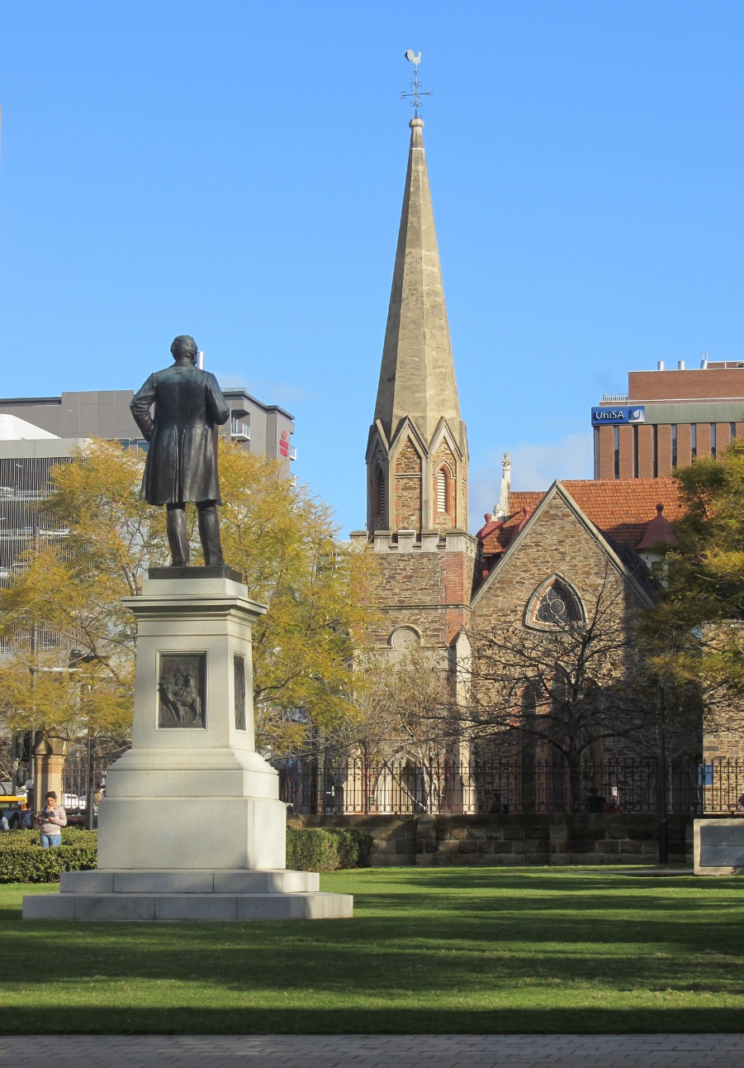

Sunday 5 July 2026

Scots Church Adelaide is a welcoming,
inclusive, and worshipping community of God,
committed to justice, learning and care,
anticipating a world transformed by the love of God.

Scots Church Adelaide acknowledges that we gather on Kaurna Country, and we pay respect to Elders past, present and emerging. We recognise and respect their culture, beliefs and relationship with the land.

Welcome

An asterisk * indicates that we stand as we are able.
We are invited to speak the words in bold italics.
Helpful instructions and explanations are in italics.
If you require the hearing loop, please sit in the middle of the centre pews.

Prelude

The music of the prelude invites us to quieten our busy minds and prepare to worship.

Anthem 11 – from The Scottish Anthem Book F.S.P.C.1

*Processing of the Bible

We stand and together bring the Bible to the centre of our worship service,
expecting to learn and be inspired.

Lighting the Candle

The candle’s flame represents the presence of God with us now and always.

Then God said, “Let there be light,” and there was light.
Light shining in the darkness

The light of creation
The light of the world

(from the Book of Genesis: 10th–5th Century BCE
and the Gospel of John: late 1st CE)

Welcome

Introduction to our anniversary
*Call to Worship (please stand)

We remind ourselves that we are here to worship God together.

Creator God, we are here, together in hope!
With community and creation

With neighbours near and far
With those known and new
Together in hope!
(from the Southern Asian Initiative of the
United Church of Christ: early 21st century CE)

Psalm 43 – tune Sawley (please remain seated)

The Hebrew Psalms are an ancient collection of poems long used in Christian worship.

(The Psalter and Church Hymnary 1898)

*Prayer (please stand)

This prayer acknowledges that God is with us and helps us experience God’s presence.

Ever-living God,
you are infinite, yet compassionate;
in you we live, and move, and have our being.
One with us in Jesus Christ,
you share our life and our death;
flowing through us as living water,
you quench our thirst.
Holy One, we adore you;
Holy Wisdom, we adore you;
Holy Spirit, we adore you;
accept the praise we bring today and for ever.
Amen.
(Uniting Church in Australia: 21st century CE)
Prayer of Confession (please stand)

We are made in the image of God, but so often do not fully live this truth. We do much to damage ourselves and each other. In confession, we acknowledge these hard truths and open ourselves to God’s forgiveness, which comes to us abundantly.

Before God, we confess in silence:

O Divine Redeemer lyrics by Charles Gounod

Assurance of Pardon and Renewal (please stand)

Friends, here is good news:
The goodness of God covers the world
as the waters cover the sea.
We are forgiven and set free
Thanks be to God.

(Uniting Church in Australia: 21st century CE)

A Hymn of Thanks Psalm 121 I to the hills will lift my eyes (please remain seated)

I to the hills will lift my eyes;
From whence shall come my aid?
My help is from the Lord a-lone,
Who heaven and earth has made.

God will not let your foot be moved,
Your guard-ian ne-ver sleeps;
God’s watch-ful and un-slumb-ering care
Pro-tects and safe-ly keeps.

Your faith-ful keep-er is the Lord,
Your shel-ter and your shade;
‘Neath sun or moon, by day or night,
You shall not be a-fraid.
From e-vil God will keep you safe,
Pro-vide for all you need;
Your go-ing out, your com-ing in,
God will for-ev-er lead.
(The Psalter and Church Hymnary 1898)

WE LISTEN FOR WHAT GOD IS SAYING TO US TODAY

In this part of our worship service, we pray that God might help us understand what we hear, we listen to parts of the Bible, and a message exploring what those words might mean for us today.

Prayer for Illumination (please stand)

May these ancient texts be a lamp to our feet
and a light to our path.

(Psalm 119: 10th – 5th century BCE)

An Introduction to the Bible readings

The Good News for today

Zechariah 9:9-12
⁹ Rejoice greatly, O daughter Zion!
Shout aloud, O daughter Jerusalem!
See, your king comes to you;
triumphant and victorious is he,
humble and riding on a donkey,
on a colt, the foal of a donkey.
¹⁰ He will cut off the chariot from Ephraim
and the war horse from Jerusalem;
and the battle bow shall be cut off,
and he shall command peace to the nations;
his dominion shall be from sea to sea
and from the River to the ends of the earth.
¹¹ As for you also, because of the blood of my covenant with you,
I will set your prisoners free from the waterless pit.
¹² Return to your stronghold, O prisoners of hope;
today I declare that I will restore to you double.

Matthew 11:25-30
²⁵ At that time Jesus said, “I thank you, Father, Lord of heaven and earth, because you have hidden these things from the wise and the intelligent and have revealed them to infants; ²⁶ yes, Father, for such was your gracious will. ²⁷ All things have been handed over to me by my Father, and no one knows the Son except the Father, and no one knows the Father except the Son and anyone to whom the Son chooses to reveal him.
²⁸ “Come to me, all you who are weary and are carrying heavy burdens, and I will give you rest. ²⁹ Take my yoke upon you, and learn from me, for I am gentle and humble in heart, and you will find rest for your souls. ³⁰ For my yoke is easy, and my burden is light.”

In sacred words of old,
we have heard the Spirit speak anew.

Sermon

Reflection: Shall we gather at the river – composer Robert Lowry
arr. Aaron Copland

A moment, aided by music, to reflect on what we have heard and said in our worship together.

WE RESPOND IN FAITH

In this part of our worship service, we commit ourselves to live out the message of love that we have heard.
*A Hymn of Dedication TiS 459 (ii) In Christ there is no east or west (please stand)

1. In Christ there is no east or west,
in him no south or north,
but one great fellowship of love
throughout the whole wide earth.

2. In Christ shall true hearts everywhere
their high communion find,
his service is the golden cord,
close-binding humankind.

3. Join hands, then, members of the faith,
whate’er your race may be;
who serves my Father as his child
is surely kin to me.

4. In Christ now meet both east and west,
in him meet south and north,
all Christlike souls are one in him
throughout the whole wide earth.

Prayers of the People (please remain seated)

We pray for our world, and we pray the prayer that Jesus taught to his disciples.

God of all goodness and compassion,
as we gather around this table of abundance,
we remember that your love knows no boundaries,
your grace excludes no one,
and your table welcomes all who hunger for justice and peace.

We pray for your church in all its beautiful diversity—
may we embody the radical hospitality of Christ,
breaking down walls that divide,
opening doors that have been closed,
and setting tables where all your beloved children find nourishment.
We pray for all who hold positions of power and influence.
Grant them wisdom to govern with compassion,
courage to speak truth to injustice,
and humility to listen to the voice of justice.

We pray for those who are hungry— those who are refugees,
and those who are unemployed and underemployed.

We pray for those facing discrimination, violence, or exclusion
because of who they are or whom they love.

As we take bread and wine, fruits of the earth and work of human hands,
we acknowledge our interconnectedness with all creation.
Inspire us to live sustainably, to protect the climate,
and to ensure that future generations inherit a world of beauty and abundance.
God of love, transform us, as we receive this sacred meal.
May the bread strengthen us for the work of justice,
and may the cup fill us with courage to love boldly.

In the name of Christ, we pray.

Amen.

(Uniting Church in Australia: 21st century CE)

The Lord’s Prayer

Let us pray:

Our Father in Heaven
hallowed be your name,
your kingdom come,
your will be done,
on earth as in heaven.
Give us today our daily bread.
Forgive us our sins,
as we forgive those who sin against us.
Save us from the time of trial
and deliver us from evil.
For the kingdom, the power, and the glory
are yours, now and forever. Amen.

(Matthew 6:9-13: 1st century CE)

Invitation to the Offering

One practical way of responding to God’s love is to contribute money to help others in need.

When we share what we have been given,
we share in the great relationship at the heart of God.

Our offering will now be received.

*Prayer of Dedication (please remain seated)

We bring our offerings to God and pray that they might be used wisely.

Loving God,
receive our gifts.
All we have comes from you.
May what we give
be for the hope of the world.
Amen.

COMMUNION

In this part of our worship service, we share the ancient symbolic meal often called the Eucharist, the Lord’s Supper or the Mass. Together we share small amounts of bread and grape juice as a sign of God’s goodness in creation and of God welcoming us into new life through the life, death, and resurrection of Jesus.
Scots Church Adelaide welcomes all people to participate in the sacrament of communion. Bread and grape juice are distributed to us in our seats.
Gluten-free bread will be available.

The Peace
The peace of the Lord be always with you.
And also with you.

Invitation
This is the joyful feast of Jesus…
…and calls you God’s own.

Prayer of Approach (please remain seated)
Be present, risen Lord Jesus…

Narrative of the Institution of the Lord’s Supper
Hear the words of institution of this sacrament as recorded by the apostle Paul…

Great Prayer of Thanksgiving (please remain seated)
The Lord be with you.
And also with you.
Lift up your hearts.
We lift them to the Lord.
Let us give thanks to the Lord our God.
It is right to give our thanks and praise.
With all we are, we give you glory, Trinity of love…
… as we join the company of heaven in their song.

Hymn: TiS 761 Holy, holy (please remain seated)
Holy, holy, holy Lord, God of power and might,
Heaven and earth are full of your glory.
Hosanna in the highest.
Blessed is the one who comes
in the name of the Lord.
Hosanna in the highest.

To Adam and Eve, children of dust…

…Through him, in him and because of him, we affirm the Church’s faith:

Christ has died.
Christ is risen.
Christ will come again.
And so, in remembrance of all you have done for us…
…we worship you in joyful song:

Blessing and honour and glory and power are yours for ever and ever. Amen.

The Breaking of The Bread
Christ is the bread of joy……let us become what we receive.
The body of Christ.
Lamb Of God
Jesus, Wisdom of God,
have mercy on us.
Jesus, Word made flesh
have mercy on us.
Jesus, Liberator of creation,
grant us peace.
The Communion
Receive this holy sacrament…

Prayer After Communion (please remain seated)
God of heaven and earth…
…In Christ’s name.
Amen

*A Hymn of Commissioning TiS 457 The church’s one foundation (please stand)

1 The church's one foundation
is Jesus Christ her Lord:
she is his new creation
by water and the word;
from heaven he came and sought her
to be his holy bride;
with his own blood he bought her,
and for her life he died.

2 Elect from every nation
yet one o'er all the earth,
her charter of salvation,
one Lord, one faith, one birth;
one holy name she blesses,
partakes one holy food,
and to one hope she presses
with every grace endued.

5 Yet she on earth has union
with God the Three in One,
and mystic sweet communion
with those whose rest is won.
O happy ones and holy!
Lord, give to us the grace
like them, the meek and lowly,
in heaven to seek your face.

WE GO IN FAITH

Our worship together now moves from this service and this place out into our hours and our days.

We continue to make community amongst us by hearing the Blessing, passing the peace and moving to the hall to share tea, coffee, and conversation.
If you are visiting with us, we invite you to join us this morning.
If you need to go, we understand.

You may wish to sign our visitors’ book as you leave.

*Affirmation

An affirmation expresses things we believe are true. We speak it aloud
to remind ourselves of our calling and to embed it in our lives.

We believe
that every human being is made in the image and likeness of God
and possesses a dignity and value which can never be taken away.

We believe
that as children of the one God
we are one family with mutual responsibility for each other

(Cardinal Basil Hume: late 20th century CE)

*Passing the Peace

We send each other out into our day in peace.

Peace be with you. And also with you

*Blessing

The Blessing reassures us that God is with us.

Go forth into the world in peace;
be of good courage;
hold fast that which is good;
render to no one evil for evil;
strengthen the faint-hearted;
support the weak;
help the afflicted;
honour all people;
love and serve the Lord,
rejoicing in the power of the Holy Spirit.
Amen.
(St. Chrysostom, The Anglican Book of Common Prayer: 20th century CE)

Choral Amen TiS 783 (ii)

*Processing the Bible
Please remain standing as you are able for the processing of the Bible.

Postlude
Before we go, we invite you to sit in contemplation as we hear the Postlude.

Highland Cathedral – composers Ulrich Roever & Michael Korb
arr. by Linus Wolf & Casey McEwan

There will be a retiring offering for Parish Relief.
Offering plates are located at the back of the church

Sources used in worship today as noted through worship booklet.
Music reproduced with permission licenses #604419-A, OneLicense,
and #496838&#352810, CCLI.

Worship leaders:

Casey McEwan — organist
Paul Turley — Minister of the Congregation
Jill Lienert — Community Connections and Development Minister
Jeffrey Schapel — member of the Church Council
Ian Vayne — cantor/soloist
Margaret Secombe — Chair of the Church Council
Jeffrey Kong — Music Director
Evelina Bruhn – Chair of the Congregation

Scots Online

If you are visiting with us today, you might like to access our services online on the worship page of our website: scotschurch.org

You can also find Paul’s blog on the Bible passages used in the sermon at: sundaybible.substack.com

About Scots Church Adelaide

Scots Church Adelaide began in 1851, formed by local supporters of the Free Church, a reform movement in the Church of Scotland that opposed political control of the church and engaged with the social changes of the 1800s, including industrialisation and urbanisation.

The church was originally named after the leader of the movement, Thomas Chalmers.

In 1865, Chalmers Free Church joined congregations of the Church of Scotland, the United Presbyterians, and the Free Church to form the Presbyterian Church of South Australia.

In 1929, the Chalmers congregation amalgamated with the Presbyterian congregation in Flinders St and took the name Scots Church Adelaide. After the church building in Flinders St was demolished, items including the organ, windows and plaques were installed in Scots Church, and the Flinders St stonework was re-used as facing for our office block.

In 1977, most of the Presbyterian Church of Australia joined with the Methodist Church of Australasia and the Congregational Church of Australia to form the Uniting Church in Australia. So, Scots Church Adelaide became a Uniting Church congregation.

Over the years, the congregation has supported many social initiatives. Today, Scots continues its commitment to the city community as a neighbour and place open to all. We host community organisations, including the SA Jazz Archive and The Big Issue. Our facilities are available for use by other community groups.

The building is the second oldest church still standing in the city. The current ministers are Rev Paul Turley, Minister of the Congregation, and Rev Jill Lienert, Minister for Community Connections. Worship services are held at 10.30am each Sunday.



SCOTS CHURCH ADELAIDE
Uniting Church in Australia

Kaurna Country 237 North Terrace, Adelaide
Ministers: Rev Paul Turley, Rev Jill Lienert
Phone 8223 1505 www.scotschurch.org
 www.facebook.com/scotschurchadelaide

